Proposal Summary – Establishing/Strengthening Facilities
- New Facility
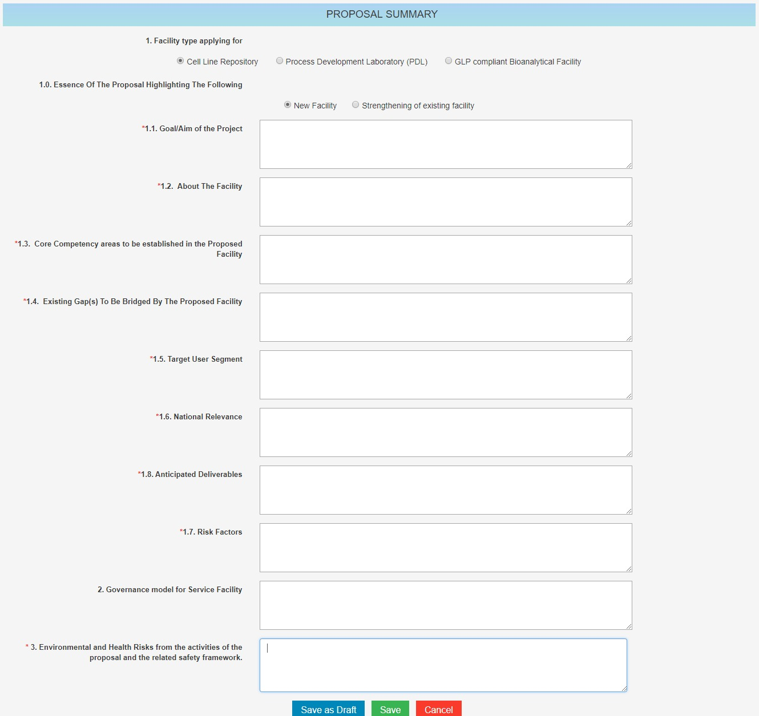

- Strengthening of existing facility
