Proposal Summary – Biosimilar Product Development
Relevant Category – Product Development
- Upto Preclinical Studies
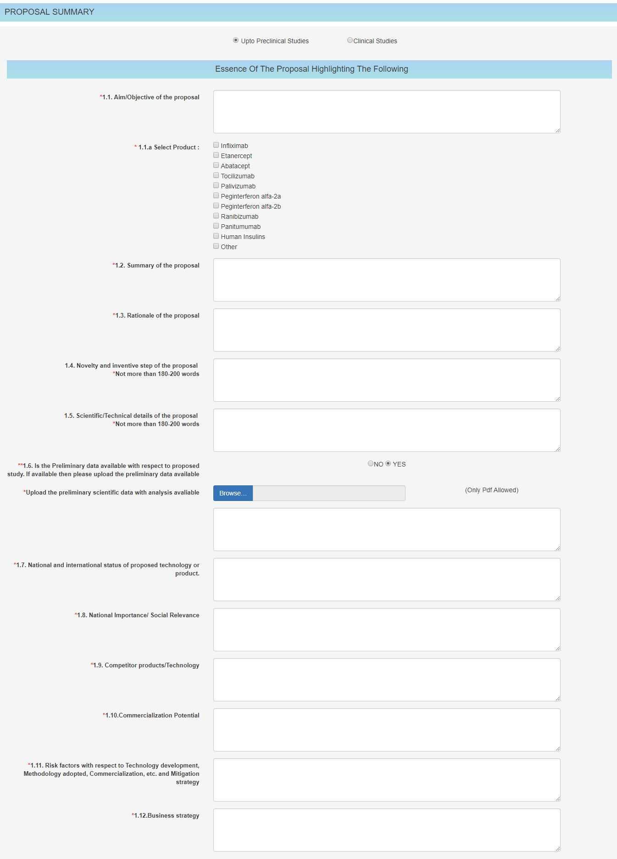
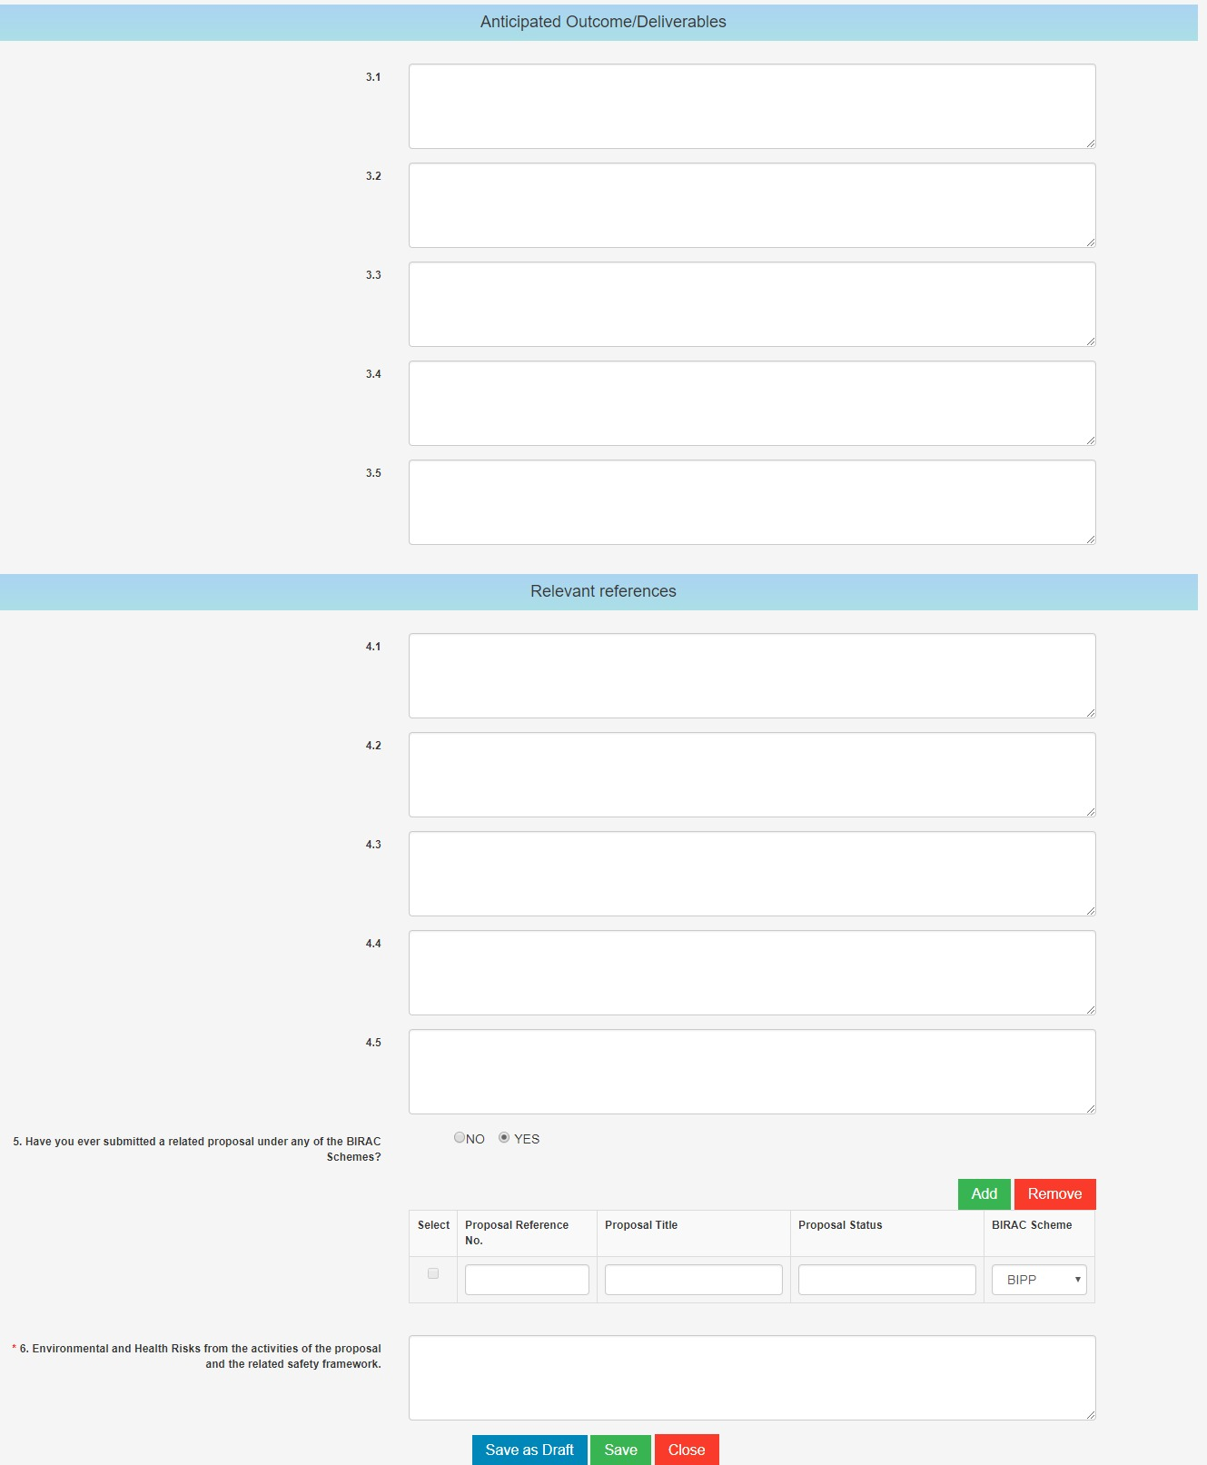
- Clinical Studies
