Proposal Summary - MedTech Facility
- Proposal Summary New Facility
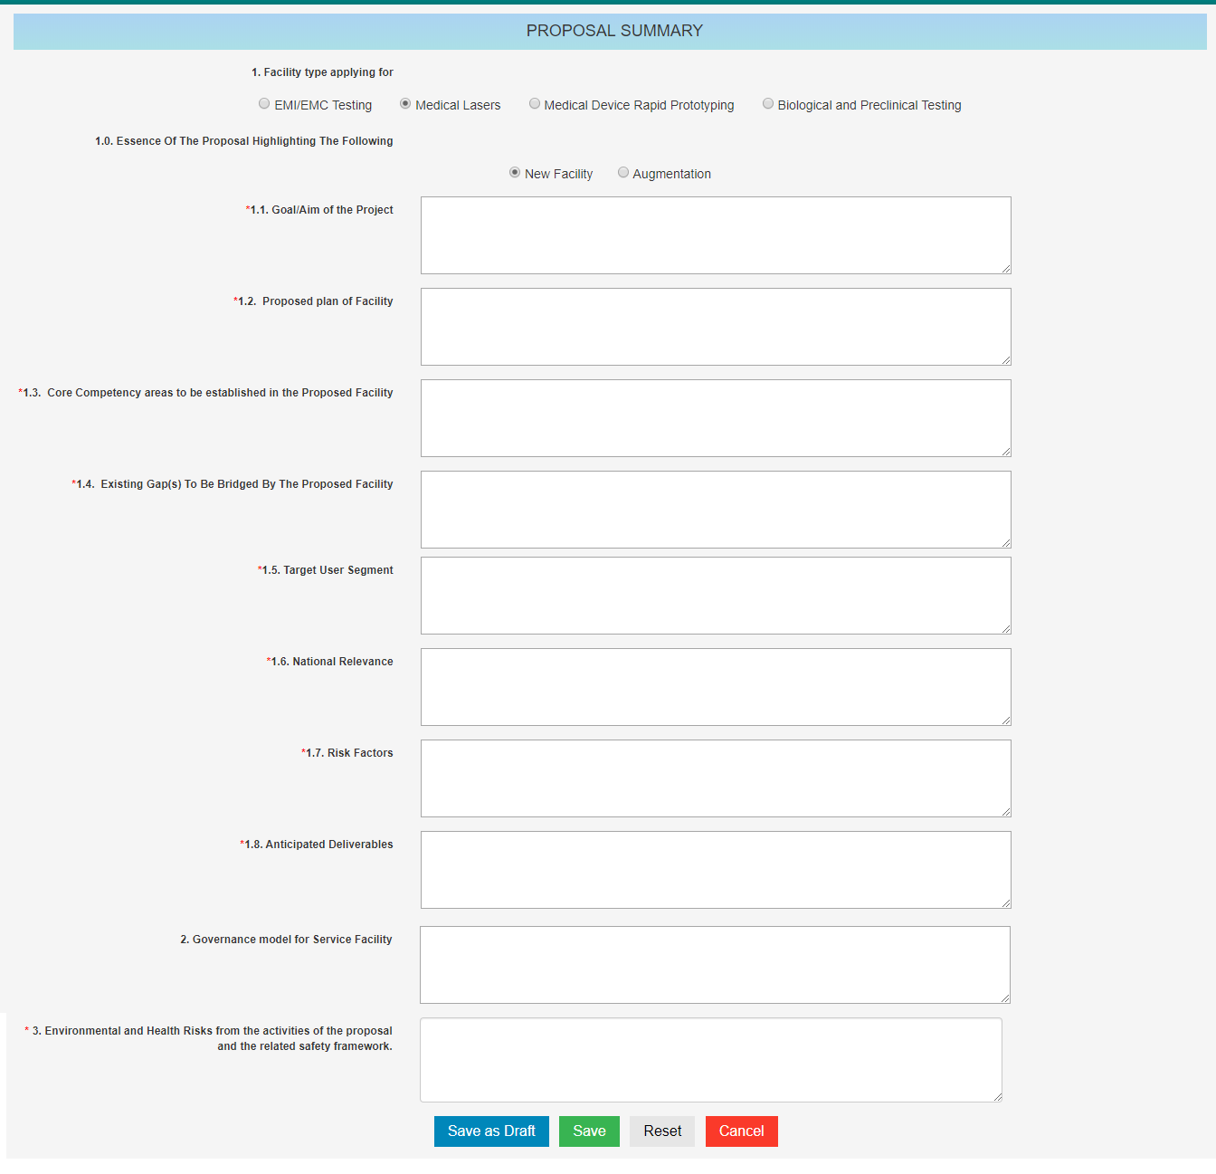

- Proposal Summary Augmentation
